EXTRA PARTS
Need to 3d PRINT:
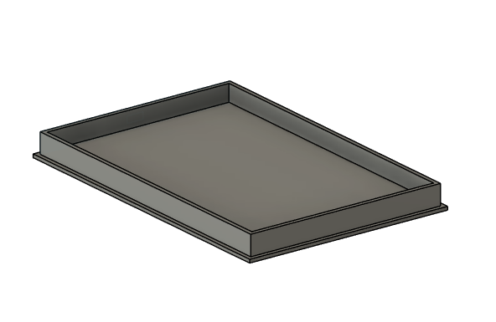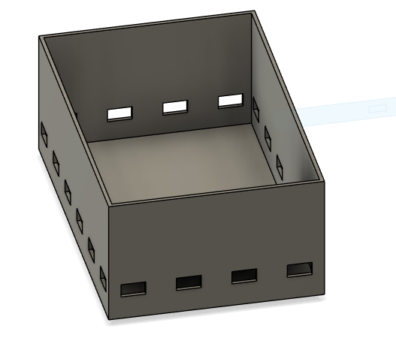
CASE FOR THE GYROSCOPE BREADBOARD AND ITS CAP
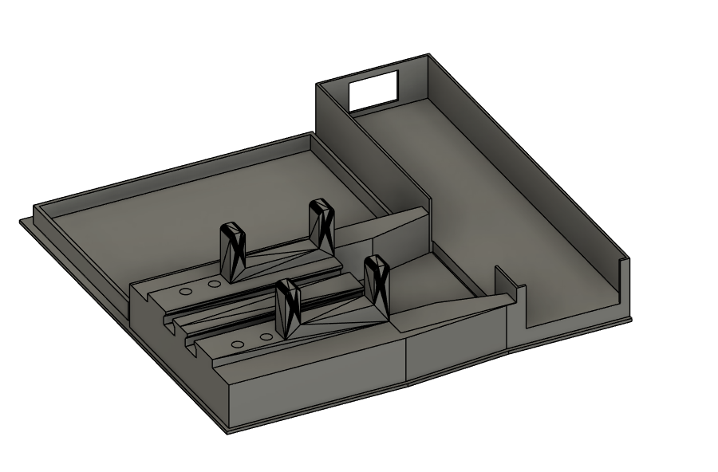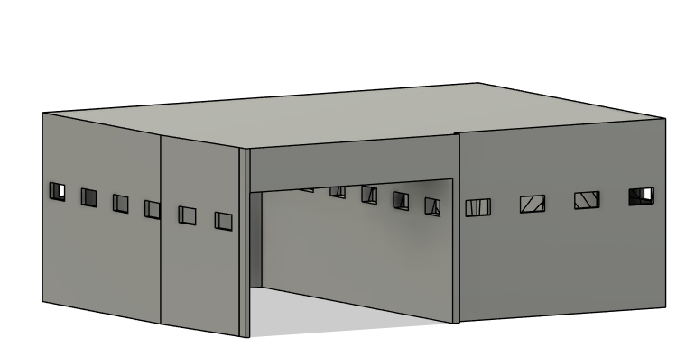
CASING FOR THE EMS/TENS MACHINE AND ITS RESPECTIVE CASE (For Servo breadboard housing)
- PARTS:
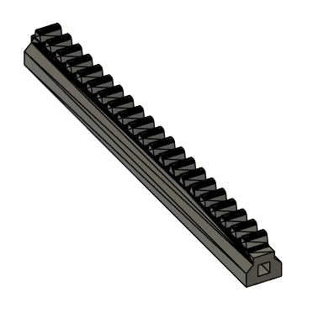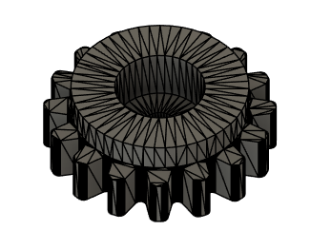
(Shaft x2) Servo Gear x2

Bill of Materials (BOM)
Esp32 DevKitC(X2)- Arduino board for coding the project and bluetooth connectivity
MG90s Servo (X2)- Servo Motor for controlling Linear Actuators
MPU6050 Gyroscope (X1)- Gyroscope for determining head rotation
Half-size Breadboard (X2)-Standard Solderless Breadboards for connecting electronics
~15 Jumper Wires (M-M) – For wiring
AVCOO EMS/TENS Unit (x1) -For electric muscle stimulation
Standard EMS/TENS Unit Self-Adhesive Electrode Pads- (COMES WITH EMS DEVICE) Used to connect to EMS and apply electric pulses to body
AA 6V battery case (X1)- Used to power the SERVO breadboard
AAA 4.5V battery case WITH POWER SWITCH (X1)- Used to power the GYROSCOPE breadboard
Velcro strap--To wear the GYROSCOPE breadboard on head

Assembly- GYROSCOPE BOARD
X1 Breadboard
X1 ESP32
X1 MPU6050 Gyroscope
Jumper Wire
3d printed Gyroscope case and cap
Velcro Strap
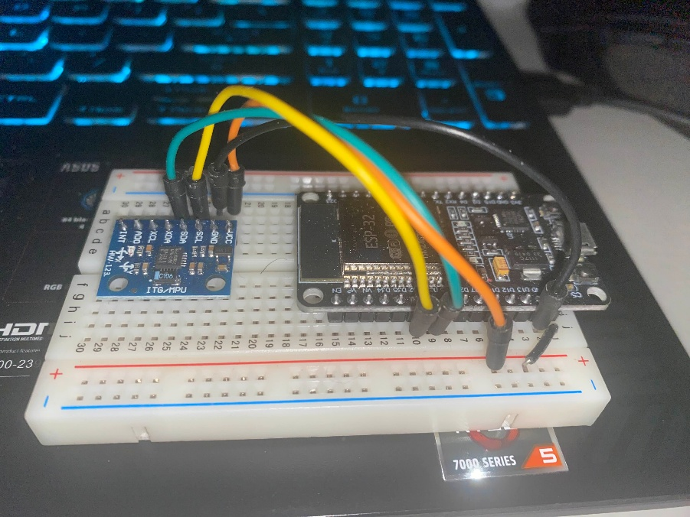

Assembly- SERVO BOARD
X1 Breadboard
X1 ESP32
X2 MGS90 Servos
X1 AVCOO EMS/TENS Machine
Jumper Wires
Micro Servo Fastners
3d printed “PARTS” above
3d printed Servo case and cap
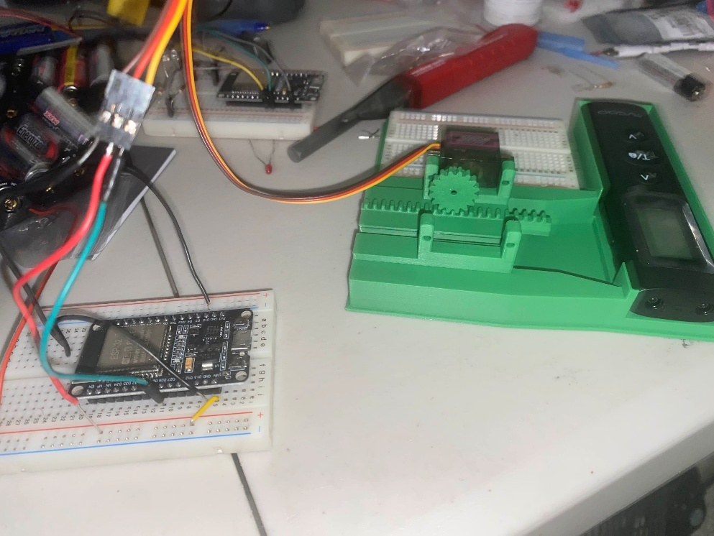

Setting up device: Master and Slave Bluetooth Coding

MASTER ESP32 (Gyroscope board)
Install VSCode and get the Platform IO Extension
Create a Project for the Master Code.
- Project settings: board- ESP32 DevkitC and code- Arduino
In the newly created project, install the MPU 6050 Library
- Also in the .IO file, add a monitor speed to 11520
Download code for Gyroscope board (ESP32 Master Code) and paste it in project.
Build and upload to the ESP32

SLAVE ESP32 (Servo board)
Create another Project for the Slave Code
- Same project settings
Install the ESP32 SERVO library along with the (FIND THE JSON BLUETOOTH LIBRARY THINGY)
- Again, add the Monitor to 11520 into the .IO file
Download code for the Slave board (ESP32 Slave Code) and paste it in project
Build and upload to the ESP32
*With both Master and Slave ESP32s done, they should be able to connect to each other, which will be signaled by a blue light appearing on both boards.

